1.Check If All 1's Are at Least Length K Places Away

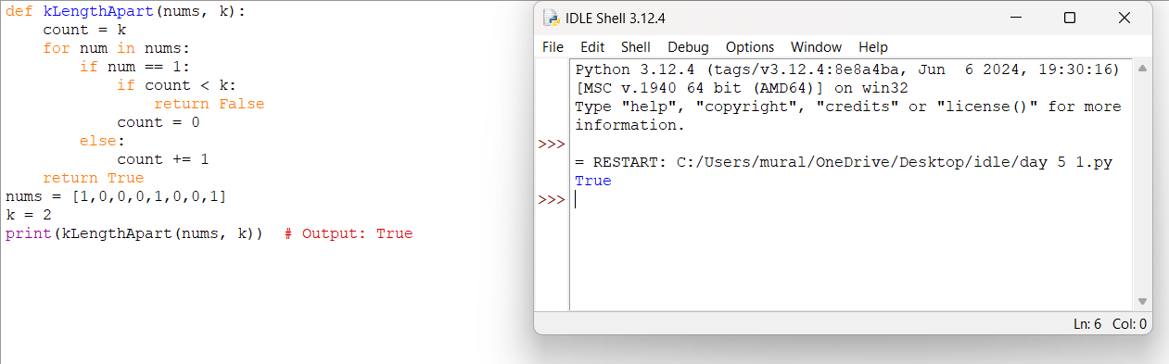

2.Longest Continuous Subarray With Absolute Diff Less Than or Equal to Limit

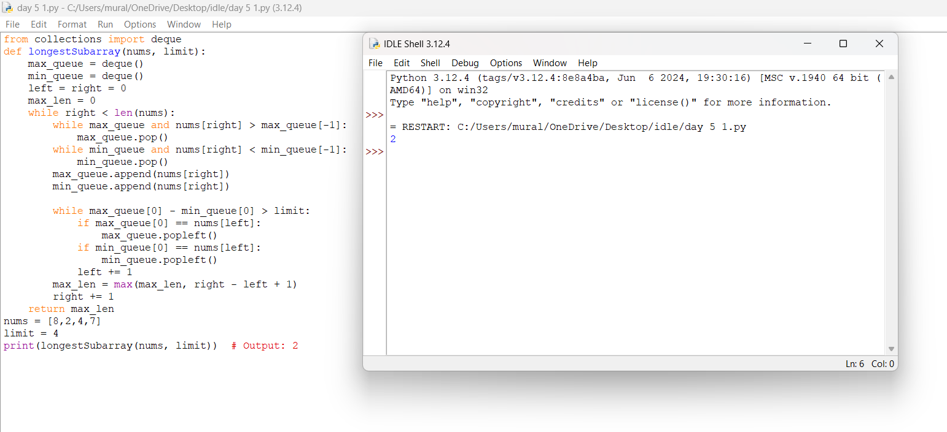

3.Find the Kth Smallest Sum of a Matrix With Sorted Rows

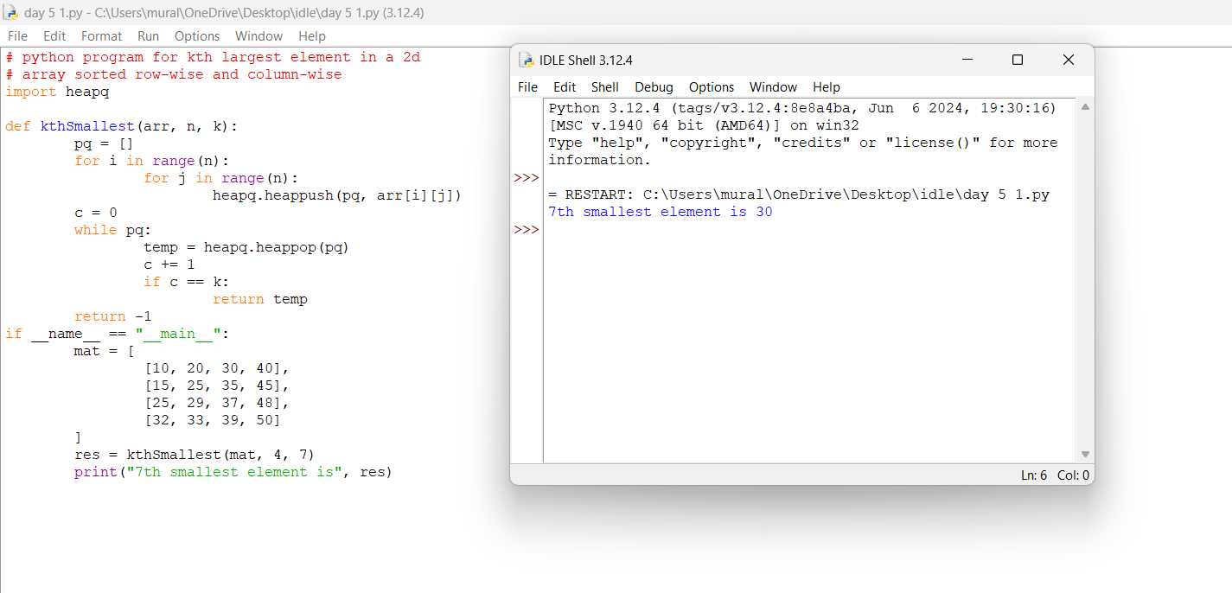

4.Evaluate Boolean Expression

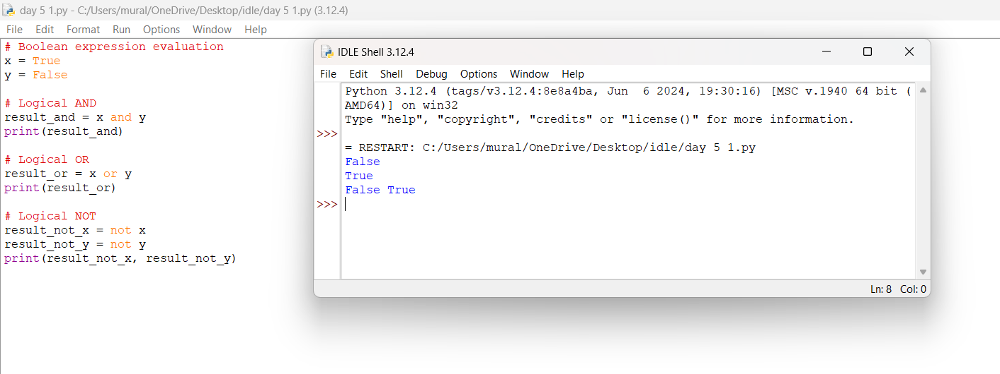

5.Build an Array With Stack Operations

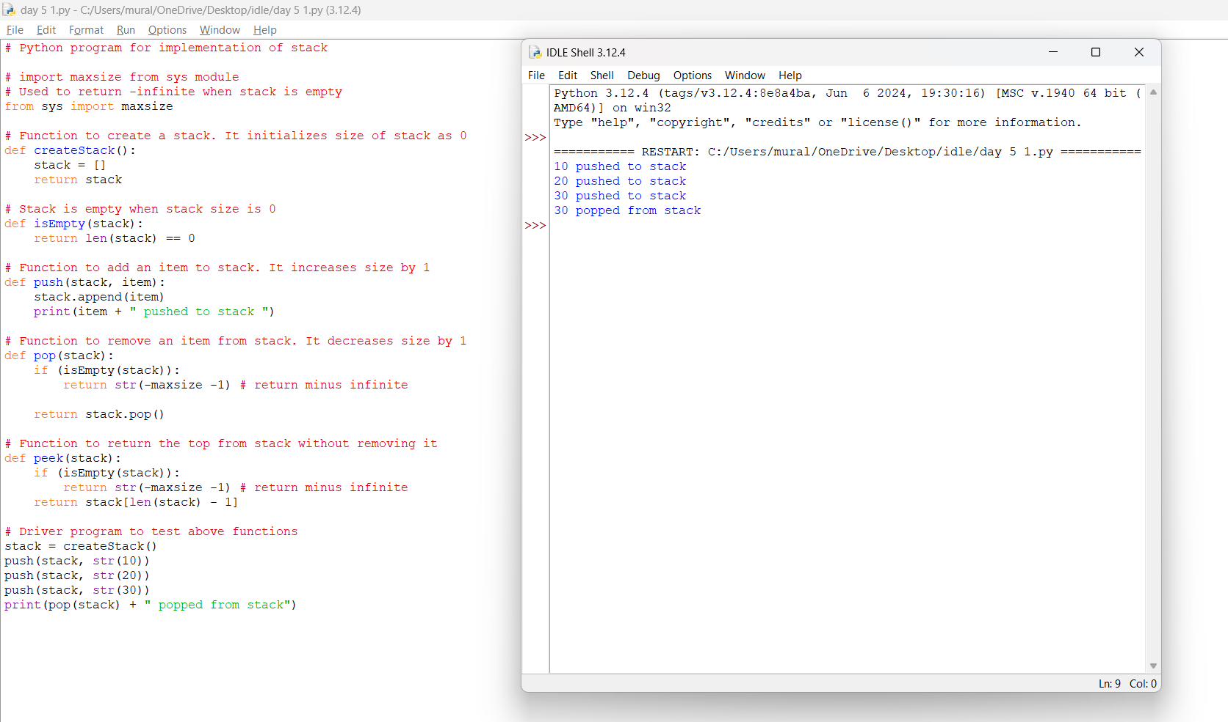

6.Count Triplets That Can Form Two Arrays of Equal XOR

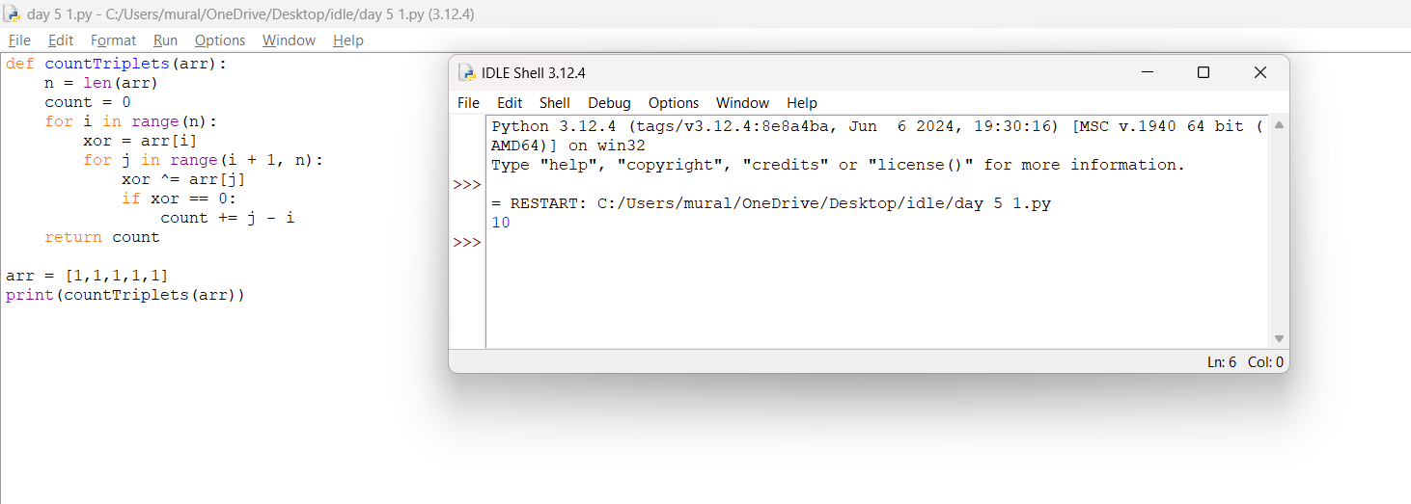

7.Minimum Time to Collect All Apples in a Tree

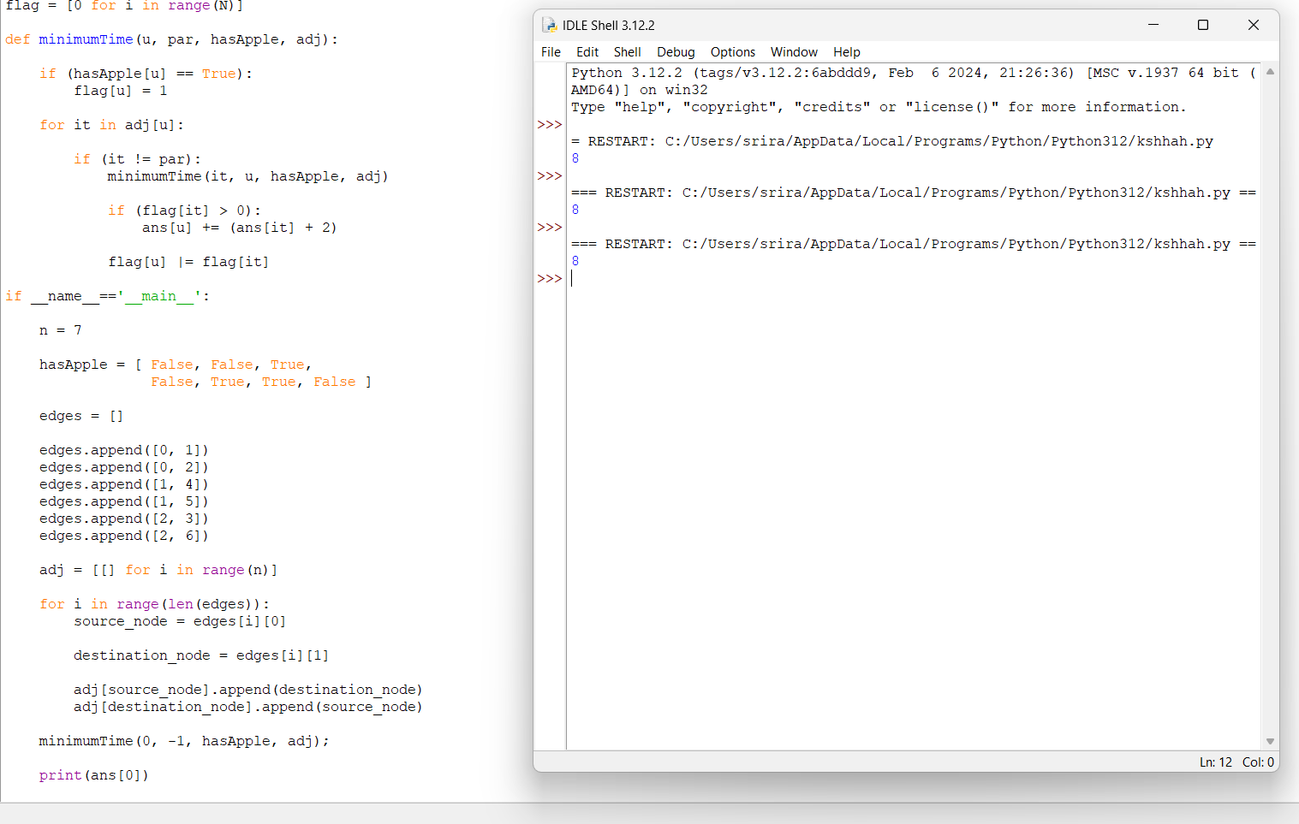

8.Number of Ways of Cutting a Pizza

